React Js

* React is a javascript library created and maintained by Facebook for building UI.
* React is used to build single page application.
* React allows us to create reusable UI components.
* React is fast compared to web apps developed in VanillaJS
- React does it by using something called Virtual DOM
- React uses JSX to write code
- JSX = JS + HTML
- React uses virtual dom. Virtual dom is a JS object Model that react uses to calculate user interface changes.

* Library vs Framework :-

- A library can be thought of as a bunch of procedures you call to accomplish a certain task. It is your program that calls into the library and is as such independent of the library. The program is the master and the library is a slave.

- A framework on the other hand is, as the name suggests, a set of rules, conventions and protocols for how a program works. It includes most of the common infrastructural code that is a large part of apps. It also imposes standard rules about how everything is done. The code written by the user of a framework just defines in an abstract way the specifics of that particular application. It does this in a way that is expected by the framework, i.e, your code has to comply to the framework's predefined conventions about how everything will work. It is the framework code that runs first and that calls into your code to determine what has to be done at a high level. The framework is the backbone of the app and defines the general architecture of the app.

-- React stands at kind of a fuzzy spot. It is a framework in the sense that it absolutely does have a predefined architecture and infrastructural design and it calls into your code to fill in the details. It is a library in the sense that it only handles the UI part of the app and tries not to handle any other aspect of the app. The entry point is controlled by the user and React does not decide any conventions for other things like state management, network functionality, data storage, etc.

* You’ll need to have Node >= 8.10 and npm >= 5.6 on your machine. If not update npm.

* To create a project, run:
- npx create-react-app my-app
- cd my-app
- npm start

* to install react and react-dom dependency
* but if you perform the above step, this is not needed
- npm install --save react-router-dom

Reactstrap

* https://reactstrap.github.io/
* adding bootstrap and reactstrap to react project
* the JS part of bootstrap cannot be directly used with react, reactstrap supplies bootstrap component re-implemented using react component.
* they both are used together to style the elements.

- npm install --save bootstrap
- npm install --save reactstrap react react-dom

Adding Font Awesome:-
- npm install font-awesome –save
Adding Bootstrap social (use to add social media buttons)
- npm install bootstrap-social –save
Adding React Router to the react project
- npm install react-router-dom --save

React Components:-

- Components are like functions that return HTML elements.
- Components are independent and reusable bits of code.
- They serve the same purpose as JavaScript functions, but work in isolation and returns HTML via a render function.
- Component name must start with capital letter.

- Class based component vs function based component:-
class App extends component{
render(){
return(
// JSX elements
);
}
}
function App(){
return(
// JSX elements
);
}
* To use props in class use {this.props.prop_name}

* To set property inside react elements use “className” intead of “class”.
* To import css in react, use import in main JS file.
- use this in the main JS file (index.js) import './style.css';

* if you want to add javaScript code inside JSX use curly braces {};

* if you want to get the varible inside the function, use dot notation, ex code

import React from 'react';
import ReactDOM from 'react-dom';

function App(){
const date = new Date();
const hours =date.getHours();
let timeofday;

if(hours < 12){
timeofday="morning"
}
else if(hours>=12 && hours<17){
timeofday="afternoon"
}
else{
timeofday="night"
}
return{
timeofday
}
}

ReactDOM.render(<h1>{App().timeofday}</h1>, document.getElementById('root'));

* the above code greets wrt time.

* inline styling in react
* remember to use camelCase for property

<h1 style={{color: "red", backgroundColor:"black"}}>hello world</h1>

*But instead use this
const styling={color: "red", backgroundColor:"black"};
<h1 style={styling}></h1>

* Components are further classified into 2 types:-
1. Presentational or stateless component
2. Container Components or stateful components

- Organizing your React app into presentational and container components
- Enable your presentational components to be concerned with the look and feel of your app
- Enable container components to deal with the state, provide the data and handle user interactions.

React Props:-

* Props are arguments passed into React components.
* Props are passed to components via HTML attributes.
* React Props are like function arguments in JavaScript and attributes in HTML.

* Ternary operators are used to check if property is present or not.
style={{display: props.question ? "block" : "none"}}
OR
style={{display: !props.question && "none"}}

* map() method in JS

-- The map() method creates a new array with the results of calling a function for every array element.

-- The map() method calls the provided function once for each element in an array, in order.

const nums=[2,4,6]
const doubles=nums.map(function(num) {
return num*2;
})
This will return on console log [4,8,12]

React States:-

* The state object is where you store property values that belongs to the component.
* When the state object changes, the component re-renders.
* Use only class based component for state

class App extends Component{
constructor(){
super()
this.state={
answer: "yes"
}
}
render() {
return(
<div>
<h1>{this.state.answer}</h1>
</div>
)
}
}

* changing state :-

class App extends Component{
constructor(){
super()
this.state={
count:0
}
this.handleclick=this.handleclick.bind(this) //method binding
}
handleclick(){
this.setState({ count :1 }) //changing the state
}

//aliter:-
this.setState((prevState) => {
return{
count: prevState.count +1 // changing the state w.r.t current state
}
})

render(){
return(
<div>
<h1>{this.state.count}</h1>
<button onClick={this.handleclick}>change</button>
</div>
)
}
}

** If you write method as arrow function then, no need to bind the method in construtor. **

React Lifecycle:-

* React component goes through the following lifecycle stages:

- Mounting :- putting element into the DOM, under Mounting these methods are called serially.

-- constructor() :- The constructor() method is called before anything else, when the component is initiated, and it is the natural place to set up the initial state and other initial values.

-- static getDerivedStateFromProps( props, state ) :- This method is called right before rendering the element(s) in the DOM.
This is the natural place to set the state object based on the initial props.
It takes state as an argument, and returns an object with changes to the state.

Eg, ReactDOM.render(<Header favcol="yellow"/>,document.getElementById('root'));
passing the value directly in the ReactDOM.render method

-- render() :- method is required, and is the method that actual outputs HTML to the DOM.

-- componentDidMount() :- method is called after the component is rendered.
Example changing the state automatically after some time.
This is where you run statements that requires that the component is already placed in the DOM.
componentDidMount(){
setTimeout(() =>{
this.setState({
isLoading: false
})
}, 3000)
}

- Updating :- A component is updated whenever there is a change in the component's state or props.

-- getDerivedStateFromProps() :-

-- shouldComponentUpdate() :- method you can return a Boolean value that specifies whether React should continue with the rendering or not.
shouldComponentUpdate() {
return false; // means any update will not be performed
}

-- render() :- method is of course called when a component gets updated, it has to re-render the HTML to the DOM, with the new changes.

-- getSnapshotBeforeUpdate( prevProps, prevState ) :- method you have access to the props and state before the update, meaning that even after the update, you can check what the values were before the update.
If the getSnapshotBeforeUpdate() method is present, you should also include the componentDidUpdate() method, otherwise you will get an error.

-- componentDidUpdate() :- method is called after the component is updated in the DOM.

- Unmounting

-- componentWillUnmount() :- method is called when the component is about to be removed from the DOM.

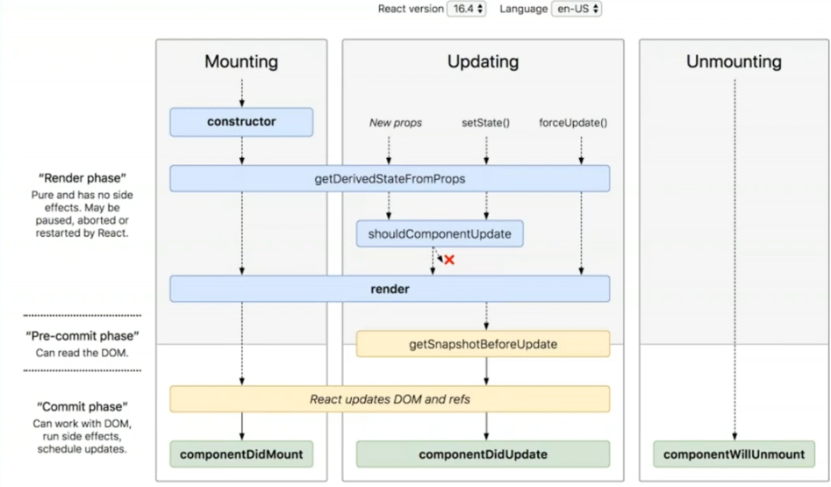

Fetching Data form an API

* Star wars API:- https://swapi.dev/api/
Eg,
componentDidMount(){
fetch("http://swapi.dev/api/people/1")
.then(response => response.json())
.then(data =>{
this.setState({
character:data
})
})

}

* Meme generator API:- https://api.imgflip.com/
* Joke API:- https://icanhazdadjoke.com/api

React Forms

* Two types of forms:-
- Controlled forms – State of the form is reflected in the state of the component.
- UnControlled forms – State of the form is retained in the DOM itself.

* Formik react library is used to make nicer forms easily.

React Fragments:-

* A common pattern in React is for a component to return multiple elements. Fragments let you group a list of children without adding extra nodes to the DOM.

* You can use <></> the same way you’d use any other element except that it doesn’t support keys or attributes. Fragments declared with the explicit <React.Fragment> syntax may have keys

MVC and Flux Architecture

- While working an a large project, it is necessary to arrage codes that is easier to debug, update, makes the codes less complex.
MVC separates an application into three components - Model, View, and Controller.
- But MVC has a drawback, it looked quite complicated on a large project
- facebook in their f8 said , while installing a new feature into their site, a bug originated, and it was diffucult to track it owing to its complexity, so they switched to the Flux Architecture.

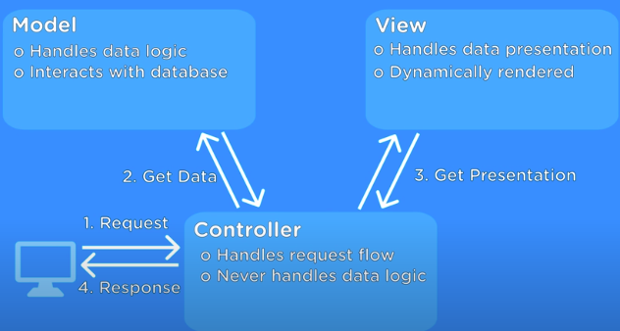

ADVANCED TOPICS

* Other modern/advanced React features/topics to learn:-

* Official React Context API - https://reactjs.org/docs/context.html
* Error Boundaries - https://reactjs.org/docs/error-boundaries.html
* render props - https://reactjs.org/docs/render-props.html
* Higher Order Components - https://reactjs.org/docs/higher-order-components.html
* React Router - https://reacttraining.com/react-router/core/guides/philosophy
* React Hooks - https://reactjs.org/docs/hooks-intro.html
* React lazy, memo, and Suspense - https://reactjs.org/blog/2018/10/23/react-v-16-6.html

Resources:-

- https://scrimba.com/g/glearnreact

- https://medium.freecodecamp.org/every-time-you-build-a-to-do-list-app-a-puppy-dies-505b54637a5d

- https://medium.freecodecamp.org/want-to-build-something-fun-heres-a-list-of-sample-web-app-ideas-b991bce0ed9a

- https://medium.freecodecamp.org/summer-is-over-you-should-be-coding-heres-yet-another-list-of-exciting-ideas-to-build-a95d7704d36d

Redux Js

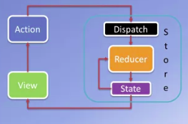

* Redux is a State Management library for javaScript apps.

Commands to install redux and react-redux:-
- npm install redux
- npm install react-redux

* Store is used to store the state , and is assessible to all parts of the UI.
* Store is an Immutable object.
* Store is incharge of calling the reducer.
* Redux can have only a single store in your application.
* we can create a store using the createStore method from Redux.
Syntax : createStore(reducer, [preloadedState], [enhancer])
- A reducer is a function that returns the next state of app.
- A preloadedState is an optional argument and is the initial state of your app.
- An enhancer is also an optional argument. It will help you enhance store with third-party capabilities.

* Reducer is used to update the state of the objects of the store.
* Actions and states are held together by a function called Reducer
* Reducer basically is a function that takes the current state of the store and moviereturn the updated store.

function reducer ( store, action ){
---- update code-----
}
* There can be many reducer functions, and each reducer function is responsible to updating specific store slices.
* Reducers in Redux should be pure functions, others can be impure
Pure function:-
- No random values
- no current date/time
- no global state( DOM, files, db, etc)
- no mutation of parameters
* You should not mutate data when making application with redux. Outside redux you can do anything.

* But, how will the reducer know, what property should it update. Here it makes the use of action.
* action are plane JS objects, that describes what just happened. Like user Login, Logout.

Steps required to build a redux application:
1. design the store
2. define the actions
3. create a reducer
4. set up the store

React-Redux forms:-

* Forms made using Redux offer several benifits compared to normal forms.
- The form information does not vanishes when the view is changed or page reloades, which in case of regular form info gets lost.
- Form data stored in Redux store in a model.
- Validation support for forms.
- React-redux also support for local form, where you can only use it for form validation and not for data persistence.
- npm install react-redux-form

Redux Thunk:-

npm install redux-thunk
npm install redux-logger :- is a redux tool for development

Resources:-

- https://www.tutorialspoint.com/redux/index.htm

Setting up JSON server:-
The Node module, json-server, provides a very simple way to set up a web server that supports a full-fledged REST API server. It can also serve up static web content from a folder.

sudo npm install -g json-server

Accessing the server:-
Type this in the json server folder

json-server --watch db.json -d 2000 -p 3001

-d 2000 represent delay to 2sec , -p 3001 represent port number it should run.

Fetch:-
* to make use of fetch add cross-fetch
npm install cross-fetch

React Animation:-
npm install react-transition-group

npm install react-animation-components
npm install prop-types

